**1.4 Uncertainty in Healthcare**

Prof Jose Miguel Hernandez-Lobato

[jmh233@cam.ac.uk](mailto:jmh233@cam.ac.uk)

<https://jmhl.org>

Most information can be found in: <http://www.cs.man.ac.uk/~fumie/tmp/bishop.pdf>

* Notes added referring to Bishop

**Bayesian approach to machine learning**

$p(θ|Data) = \frac{p(θ|Data)p(θ)}{p(Data)}$ A

$P(Y|Data) = \int{}p(Y|θ)p(θ|Data)dθ.$

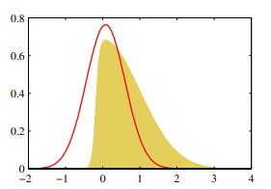

**Variational Inference**

<https://gregorygundersen.com/blog/2018/04/29/reparameterization/>

**Monte-Carlo Methods**

Metropolis-Hastings

11.2.2 The Metropolis-Hastings algorithm

Ian Murray (<https://homepages.inf.ed.ac.uk/imurray2/teaching/09mlss/slides.pdf>)

Monte-Carlo methods example: Linear regression with spike and slab priors

<https://link.springer.com/article/10.1007/s10994-014-5475-7#citeas>

Pros and Cons of Monte-Carlo methods:

* Advantage:
  + More accurate than Laplace, EP, and VI
    - When enough computation time
  + Theoretical results guarantee asymptotic convergence to the true posterior
  + Simple and easy to implement
    - Better than EP but worse than VI
  + Disadvantages:
    - Hard to debug and check for convergence
    - Requires hyper-parameters
      * Need to be tuned in a non-straightforward manner
    - Slower than Laplace, VI and EP generally